GeneralInstructions (a) All questions are compulsory.
(b) Section A: Q.no. 1 to 20 is very short answer questions (objective type) and carry 1 mark each. (c) Section B: Q.no. 21 to 27 are short answer questions and carry 2 marks each.
(d) Section C: Q.no. 28 to 34 are long answer questions and carry 3 marks each.
(e) Section D: Q.no. 35 to 37 are also long answer questions and carry 5 marks each.
(f) There is no overall choice. However an internal choice has been provided in two questions of two marks, two questions of three marks and all the three questions of five marks weightage.
You have to attempt only one of the choices in such questions.
(g) Use log tables if necessary, use of calculators is not allowed.
SECTION – A
Read the given passage and answer the questions 1 to 5 that follow:

A carbonyl group is defined as, a carbon atom attached to oxygen atom with double bond. The carbonyl group is a trigonal planar structure. This is because of the bond angle between the atoms attached to carbonyl group. The bond angle between the atoms predicted as per VSEPR theory is 120 degree. Both aldehydes and Ketones have carbonyl group.
- Name the type of interaction found between the molecules of aldehydes and ketones.
- Why is nucleophilic addition impossible in aldehydes?
- Arrange the following compounds in the increasing order of boiling points:
CH₃CH₂CH₃, CH₃CH₂OH, CH₃OCH₃, CH₃CHO
- Arrange the following in the increasing order of dipole moment:
CH₃CHO, (CH₃)₂CO, CH₃CO OH
- What is the order of reactivity of the following towards HCN?
C₆H₅CHO, C₆H₅CO C₆H₅, CH₃CHO, HCHO
Questions 6 to 10 are one word answers:
- Which of the following compounds would undergo cannizzaro reaction:
Benzaldehyde, Cyclohexanone, 2- Methylpentanal.
- Lower alcohols are soluble in water. Why?
- What is Hinsberg reagent?
- Why is sulphuric acid not used during the reaction of alcohols with KI?
- Arrange the compounds of each set in order of reactivity towards SN2 displacement: a) 2-Bromo-2-methylbutane, 1-Bromopentane, 2-Bromopentane.
Questions 11 to 15 are multiple choice questions:
- The correct IUPAC name for CH₂ = CHCH₂NHCH₃ is
- Allyl methylamine
- 2-amino-4-pentene
- 4-aminopent-1-ene
- N-methylprop-2-en-1-amine
- Monochlorination of toluene in sunlight followed by hydrolysis with aq. NaOH yields.
  - o-Cresol
  - m-Cresol
  - 2, 4-Dihydroxytoluene
  - Benzyl alcohol
- Which of the following is an example of vic-dihalide?
  - Dichloromethane
  - 1,2-dichloroethane
  - Ethylidene chloride
  - Allyl chloride
- Proteins are found to have two different types of secondary structures viz. α-helix and β-pleated sheet structure. α-helix structure of protein is stabilised by :
  - Peptide bonds
  - van der Waals forces
  - Hydrogen bonds
  - Dipole-dipole interactions
- Compounds A and C in the following reaction are __________.
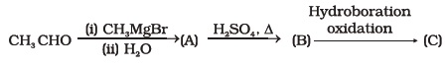
  - identical
  - positional isomers
  - functional isomers
  - optical isomers
Questions 16 to 20 :
(A) Both assertion and reason are correct statements, and reason is the correct explanation of the assertion.
(B) Both assertion and reason are correct statements, but reason is not the correct explanation of the assertion.
(C) Assertion is correct, but reason is wrong statement.
(D) Assertion is wrong, but reason is correct statement.
16. Assertion: Compounds containing —CHO group are easily oxidised to corresponding carboxylic acids.
Reason: Carboxylic acids can be reduced to alcohols by treatment with LiAlH⁴.
17. Assertion: Aldehydes and ketones, both react with Tollen’s reagent to form silver mirror.
Reason: Both, aldehydes and ketones contain a carbonyl group.
18. Assertion: Phosphorus chlorides (tri and penta) are preferred over thionyl chloride for the preparation of alkyl chlorides from alcohols.
Reason: Phosphorus chlorides give pure alkyl halides.
19. Assertion: Ethanol is a weaker acid than phenol.
Reason: Sodium ethoxide may be prepared by the reaction of ethanol with aqueous NaOH.
20. Assertion: N, N-Diethylbenzene sulphonamide is insoluble in alkali.
Reason: Sulphonyl group attached to nitrogen atom is strong electron withdrawing group.
SECTION: B

21. Why is NH₂ group of aniline acetylated before carrying out nitration?
22. Which of the following compounds (a) and (b) will not react with a
mixture of NaBr and H₂SO₄. Explain why?
23. Compound ‘A’ with molecular formula C₄H₉Br is treated with aq. KOH
solution. The rate of this reaction depends upon the concentration of the
compound ‘A’ only. When another optically active isomer ‘B’ of
this compound was treated with aq. KOH solution, the rate of reaction was
found to be dependent on concentration of compound and KOH both.
(i) Write down the structural formula of both compounds ‘A’ and ‘B’.
(ii) Out of these two compounds, which one will be converted to the
product with inverted configuration.
24. Write steps to carry out the conversion of phenol to aspirin.
25. a. Carboxylic acids contain carbonyl group but do not show the
nucleophilic addition reaction like aldehydes or ketones. Why?
b. Why are carboxylic acids more acidic than alcohols or phenols although
all of them have hydrogen atom attached to a oxygen atom (—O—H)?
26. a. Aldopentoses named as ribose and 2-deoxyribose are found in nucleic acids. What is
their relative configuration?
b.Which sugar is called invert sugar? Why is it called so?
27. a. What happens when benzene diazonium chloride is heated with water?
b. Arrange the following compounds in decreasing order of acidity. H₂O, ROH, HC ≡ CH
28. a. Why is the reactivity of all the three classes of alcohols with conc. HCl
and ZnCl₂ (Lucas reagent) different?
b. Nitration is an example of aromatic electrophilic substitution and its rate depends
upon the group already present in the benzene ring. Out of benzene and phenol, which
one is more easily nitrated and why?
29. a. Which of the products will be major product in the reaction given below?
Explain.
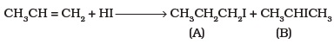
b. Draw other resonance structures related to the following structure and
find out whether the functional group present in the molecule is ortho,
para directing or meta directing.
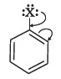
30. a. Arrange the following in decreasing order of their acidic strength. Give explanation for the
arrangement.
C₆H₅COOH, FCH₂COOH, NO₂CH₂COOH
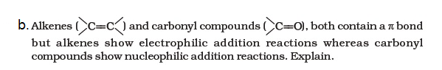
31. a. Write IUPAC names of the following structures.
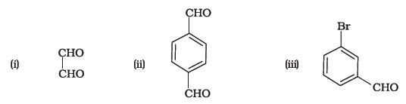
b. Give the IUPAC names of the following compounds:

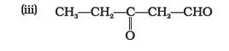
32. Write a note on:
a. Gatterman Koch reaction b. Aldol condensation reaction
33. a. Write the mechanism of:
b. Give the test for Ketone.
34. Account for:
a. Aniline does not undergo Friedel craft’s reaction with AlCl₃
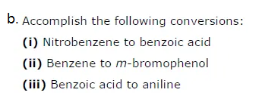
35. Write down functional isomers of a carbonyl compound with molecular formula C₃H₆O. Which isomer will react faster with HCN and why? Explain the mechanism of the reaction also. Will the reaction lead to the completion with the conversion of whole reactant into product at reaction conditions? If a strong acid is added to the reaction mixture what will be the effect on concentration of the product and why?
36. (a) Name the starting material used in the industrial preparation of phenol.
(b) Write complete reaction for the bromination of phenol in aqueous and non aqueous medium.
(c) Explain why Lewis acid is not required in bromination of phenol?
37. a. Some halogen containing compounds are useful in daily life. Some compounds of this class are responsible for exposure of flora and fauna to more and more of UV light which causes destruction to a great extent. Name the class of these halo compounds. In your opinion, what should be done to minimise harmful effects of these compounds.
b. Some alkyl halides undergo substitution whereas some undergo elimination reaction on treatment with bases. Discuss the structural features of alkyl halides with the help of examples which are responsible for this difference.

